Information for Parents and Carers
We appreciate the cost-of-living crisis is providing a challenge for many of us and as such we continue to extend our offer of support, help and signposting to specific services that may be able to help.
Below you will find some information that be useful to you. Alternatively, please do contact the Safeguarding and Wellbeing Team at the Sixth Form who are able to support your further. Please do be aware that during the holiday periods the Safeguarding and Wellbeing Team may not be able to respond to emails or telephone queries raised as the Sixth Form may be closed, however we will endeavour to respond to you query or concern as quickly as possible.
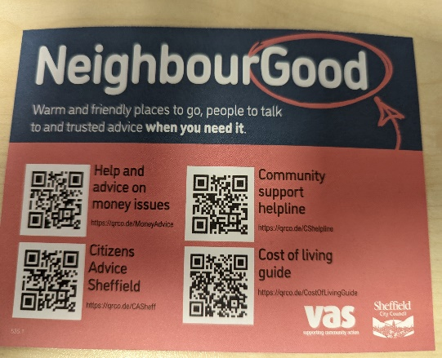
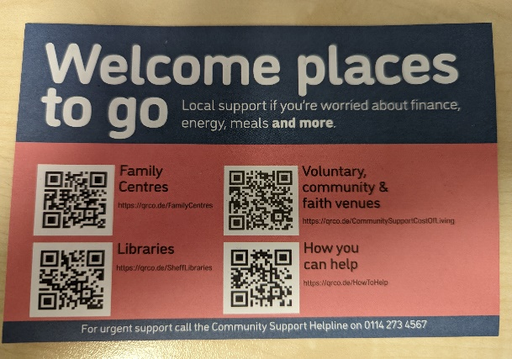

North Sheffield Activity Directory (soarcommunity.org.uk)
Benefits Calculator - entitledto - independent | accurate | reliable

Universal Credit Help to Claim Line:

0800 144 8444
Today's opening times: 8am - 6pm

Advice Line:

0808 278 7820

Hardship support

Household Support Fund
If you live in Sheffield and are struggling to afford food and other essentials, the fund can help to support you with:
- food and housekeeping (groceries, toiletries, baby essentials etc)
- telephone and broadband (mobile phones, top-ups, broadband charge etc)
- gas and electricity
- clothing, including school uniforms
- white goods
- wider essential needs not linked to energy and water should Authorities consider this appropriate in their area

Discretionary Housing Payment and Council Tax Hardship Scheme
This scheme can help you if you get Housing Benefit, but you still need help to pay your rent. You can also get help to pay your Council Tax if you get Council Tax Support

Local Assistance Scheme
This scheme provides Independence Grants to support independent living and Sheffield Crisis Grants to help Sheffield residents in crisis situations who aren't receiving help.

Warm Home Discount
You could get £140 off your electricity bill for winter 2021 to 2022 under the Warm Home Discount Scheme if you get the Guarantee Credit element of Pension Credit or are on a low income and meet your energy supplier's criteria for the scheme.
You may be able to get the discount on your gas bill instead if your supplier provides you with both gas and electricity.

The Affordable Warmth Obligation
You might be able to get help for energy-saving improvements to your home if you either:
- claim certain benefits and live in private housing (for example you own your home or rent from a private landlord)
- live in social housing

WaterSure
WaterSure is a scheme which helps some people with their water bills.
To qualify for WaterSure you need to:
- be on a water meter or have applied for one and be waiting for it to be installed, or be paying an assessed charge because it's not possible to fit a meter at your property
- be on certain benefits
- have a high essential use of water

National Debtline
- If you need advice about Individual Voluntary Arrangements (IVAs) or other bankruptcy issues, visit the Insolvency Service website.
- National Debtline provides free, independent, confidential and impartial advice by telephone on 0808 808 4000, Monday to Friday from 9am to
8pm and Saturday from 9:30 am to 1pm.

Grants to help pay off your energy debts
If you’re in debt to your energy supplier, you might be able to get a grant to help pay it off.
The following energy suppliers offer grants to their customers:
- British Gas Energy Support Fund - apply for a grant on the British Gas Energy Trust website
- Scottish Power Hardship Fund - apply for a grant on the Scottish Power Hardship Fund website
- Ovo Energy Fund - apply for a grant on the Ovo Energy Fund website
- E.ON Energy Fund - apply for a grant on the E.ON Energy Fund website

- E.ON Next Energy Fund - apply for a grant on the E.ON Next Energy Fund website
- EDF Energy Customer Support Fund - sign up to the priority services register to apply for a grant on the EDF Energy website
- Bulb Energy Fund - apply for a grant on the Bulb Energy Fund website
- Octopus ‘Octo Assist Fund’ - apply for a grant on the Octopus website
- Shell Energy Support Fund - apply for help on the Shell Energy website
If your supplier isn’t listed it’s a good idea to contact them directly to see what extra support they can give you.
If you can’t get a grant from your supplier, you might be able to get a grant from the British Gas Energy Trust. These grants are available to anyone - you don’t have to be a British Gas customer. You’ll need to get debt advice before applying - get help from a debt adviser.
If you've already spoken to a debt adviser - check if you can get a grant from the British Gas Energy Trust.
Health
Sheffield IAPT (iaptsheffield.nhs.uk)
Sheffield Samaritans
IDAS Helpline (Domestic Abuse Service) - 08088082241

